## **Microbial Data Analysis for Biological Age Prediction**

### **Introduction**

The aim of this project is to utilize microbial data to predict biological age using various machine learning models. The dataset comprises information from 'Ages.csv' and 'data.csv', merged on 'Sample Accession' and preprocessed to handle missing values and irrelevant columns.

### **Data Preprocessing**

The merged dataset underwent preprocessing steps including:

* Merging datasets on 'Sample Accession'
* Dropping rows with null values
* Removing redundant columns ('Sample Accession.1')

### **Feature Selection and Scaling**

Feature selection was performed using the Random Forest Regressor to identify the top 100 features most relevant for predicting biological age. These features were then standardized using StandardScaler. The correlation matrix of the selected features was visualized using a heatmap.

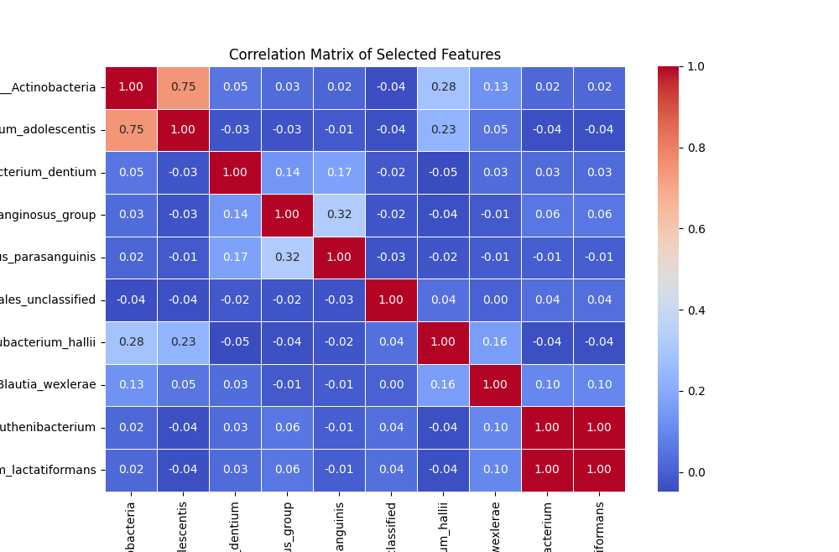

### **Dimensionality Reduction**

Principal Component Analysis (PCA) was applied to reduce the dimensionality of the selected features to 10 principal components, aiding in capturing the variance of the data while reducing computational complexity.

### **Model Selection and Tuning**

#### **Support Vector Machine (SVM) Regressor**

GridSearchCV was used to fine-tune the SVM model parameters (C, gamma, kernel type). The model’s effectiveness in predicting biological age was evaluated using MAE and R-squared.

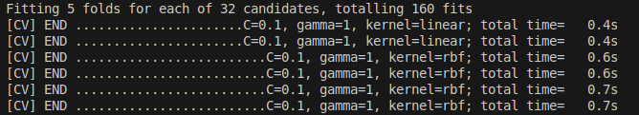

#### **Gradient Boosted Trees (GBT) Regressor**

Similar to XGBoost, GBT model hyperparameters (n_estimators, learning_rate, max_depth, subsample) were optimized using GridSearchCV. The model performance was measured using MAE and R-squared.

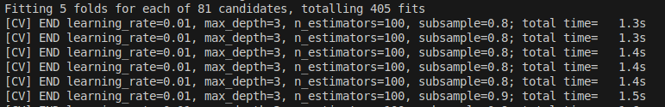

#### **Random Forest Regressor**

The Random Forest model was tuned using GridSearchCV to find the optimal number of estimators, maximum depth, minimum samples split, and minimum samples leaf. The performance was evaluated based on MAE and R-squared.

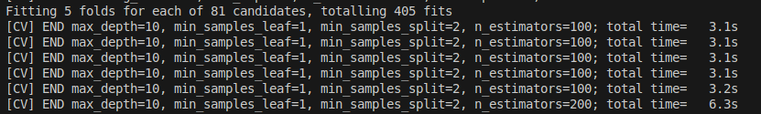

#### **Ensemble Model**

An ensemble model (VotingRegressor) was constructed using the best-performing individual models (RF, GBT, SVM). PCA-transformed features were used to train and test the ensemble model, evaluating its performance with MAE and R-squared.

### **Model Performance on Test Data**

The performance metrics for each model on the test data were as follows:

* **SVM:** MAE = 12.92 R-squared = 0.13 Accuracy = 72.42%
* **Gradient Boosted Trees Regressor:** MAE = 13.16 R-squared = 0.15 Accuracy = 71.92%
* **Random Forest Regressor:** MAE = 12.97 R-squared = 0.14 Accuracy = 72.31%
* **Ensemble Model (RF, GBT, SVM):** MAE = 12.86 R-squared = 0.16 Accuracy = 72.56%

### **Cross-validated Results**

Cross-validation results were obtained to assess the robustness of each model:

* **SVM:** Cross-validated MAE = 14.18 Cross-validated R-squared = -0.02 Cross-validated Accuracy = 69.86%
* **Gradient Boosted Trees Regressor:** Cross-validated MAE = 13.08 Cross-validated R-squared = 0.11 Cross-validated Accuracy = 72.20%
* **Random Forest Regressor:** Cross-validated MAE = 13.02 Cross-validated R-squared = 0.12 Cross-validated Accuracy = 72.31%
* **Ensemble Model (RF, GBT, SVM):** Cross-validated MAE = 13.87 Cross-validated R-squared = 0.00 Cross-validated Accuracy = 70.51%

### **Conclusion**

In conclusion, the ensemble model combining Random Forest, Gradient Boosted Trees, SVM demonstrated the best predictive performance for biological age estimation based on microbial data. Each model was rigorously evaluated through both traditional test metrics and cross-validation to ensure reliability and generalizability. Further optimization or additional feature engineering could potentially enhance model performance.

### **Visualizations**

Included are visual representations (scatter plots) illustrating the predicted versus actual biological ages for each model:

1. **SVM Model: Real Age vs Predicted Age**

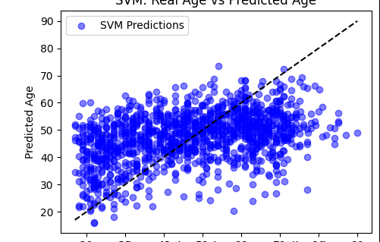

1. **Gradient Boosted Trees Model: Real Age vs Predicted Age**

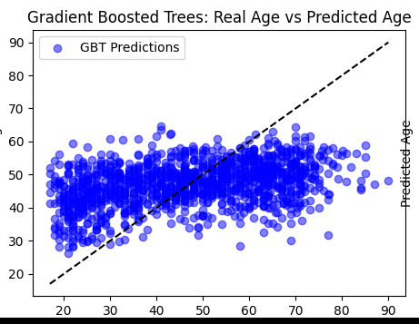

1. **Random Forest Model: Real Age vs Predicted Age**

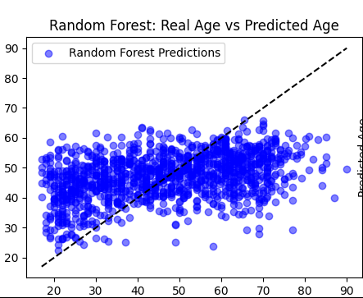

1. **Ensemble Model: Real Age vs Predicted Age**

